**Multimadia**

**Prepared by:**

**Howaida Allam Fouad**

This project consists of five algorithms, they are:

1. Run Length Code (RLC).
2. Variable Length Code (VRLC).
3. Huffman Code.
4. Adaptive Huffman Code.
5. LZW.

# **This is the Main page :**

It contains the five algorithms

# **RLC :**

It is the first algorithm and it contains:

* a button for Encode
* another for Decode

* **Encode for RLC:**

Input: AAAAAAAAAAAAAAAAABBBNNNBBBAAAAAAA

Output : 9A3B3N3B7A

* **Decode for RLC:**

Input : 9A3B3N3B7A

Output : AAAAAAAAAAAAAAAAABBBNNNBBBAAAAAAA

# **VRLC :**

The second algorithm consists of a button to draw and a button to display the number of bits used

* **Drawing:** Input >> Hello

* **Graphical user interface

  Description automatically generatedShow number of bits and the code**

# **Huffman Code:**

The third algorithm consists of a button to draw and a button to display the number of bits used.

* 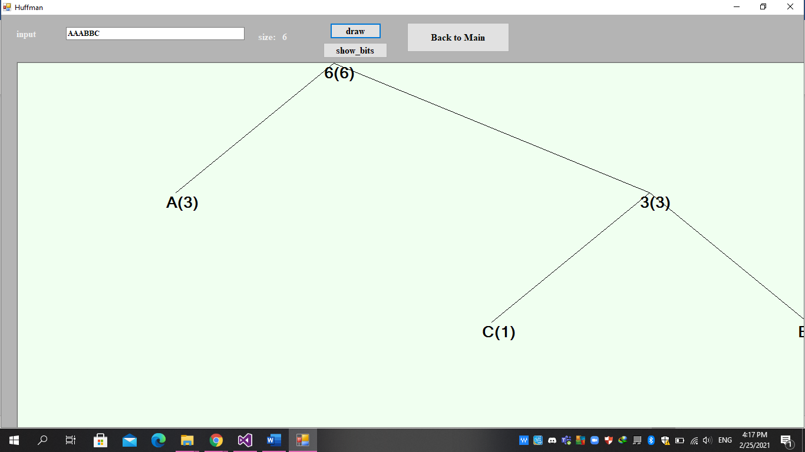**Drawing:** Input >> AAABBC
* **A computer screen shot

  Description automatically generated with low confidenceShow number of bits and the code:**

# **Adaptive Huffman:**

The fourth algorithm consists of a TextBox to write the sequence and a button to clear.

* **During Run:**

Input : AADCCDD

# **LZW:**

The fifth algorithm consists of one button for the Encode and another for the Decode.

* **Encode:**

Input : ABABBABCABABBA

Output: 1 2 4 5 2 3 4 6 1

* **Decode:**

Output: ABABBABCABABBA

